Confidence Interval: Practice 1; Confidence Intervals
for Averages, known population standard deviation

Student Learning Outcomes:

- The student will explore the properties of the confidence intervals for porportions

Given:

The average age for all Foothill College students for Fall 2005 was 32.7. The population standard deviation has been pretty consistent at 15. Twenty-five Winter 2006 students were randomly selected. The average age for the sample was 30.4. We are interested in the true average age for Winter 2006 Foothill College students. (http://research.fhda.edu/factbook/FHdemofs/Fact_sheet_fh_2005f.pdf)
Let X = the age of a Winter 2006 Foothill College student
Estimated Distribution

1. = __________ 2. n = ________ 3. 15 = ___________ (fill in symbol)

4. Define the Random Variable,, in words.
= ___________________________________________________________

5. What is estimating?

6. Is σ_{x} known?

7. As a result of your answer to (4), state the exact distribution to use when calculating the Confidence Interval.

Explaining the Confidence Intervals

Construct a 95% Confidence Interval for the true average age of Winter 2006 Foothill College students.

8. How much area is in both tails (combined)? α = __________

9. How much area is in each tail? 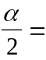 __________

10. Identify the following specifications
a. lower limit = ________
b. upper limit = ________
c. error bound = ________

11. The 95% Confidence Interval is: _____________________

12. Fill in the blanks on the graph with the areas, upper and lower limits of the Confidence Interval, and the sample mean.
______ C.L. = ______ ______
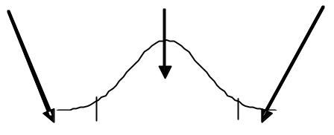
____ ____ ____

13. In one complete sentence, explain what the interval means.

Discussion Questions

14. Using the same mean, standard deviation and level of confidence, suppose that n were 69 instead of 25. Would the error bound become larger or smaller? How do you know?

15. Using the same mean, standard deviation and sample size, how would the error bound change if the confidence level were reduced to 90%? Why?

